Bilan sanitaire d’orientation – Enfant mineur

Health Record - Child

Code du centre | N° d’ordre
Code of center Sequence n°

N° dossier de l’enfant : __/__/ - __/__/__/ __/__/__/
Child file n° Départt - 1^{ères} lettres du centre
Beginning – First letters of the center

N° d’ordre des dossiers : de la mère : __/__/__/ du père : __/__/__/
File sequence N° mother’s father’s

Reporter ces numéros page suivante
Repeat this Nº on following page

Nom (majuscules) : ……………………………………………………………………………………………………….
Family Name (capitals)

Prénom (majuscules) : ………………………………………………………………………………………………….
Given Name (capitals)

Nom des parents si différent (majuscules) : ……………………………………………………………………
Parents’ names if different (capitals)

Nom de l’infirmier(e) : ____________________________________________________
Name of health center (city/department)
Opérateur : □ Samusocial □ Croix Rouge Française
Provider Samusocial French Red Cross

Nom du centre (ville/département) : _________________________________________
Name of health center (city/department)

Date de la rencontre : __/__/ __/__/ __/__/__/__/
Date of health record

Reporter la date page suivante
Repeat date on following page

 | A – Repères|Basic information |  |  |  |  |  |  |  |  |  |  |  |  |  |  |  |  |  |  |  |  | Réservé au
 |  |  |  |  |  |  |  |  |  |  |  |  |  |  |  |  |  |  |  |  |  | codage
 | Reporter les N° figurant sur la page de garde : Code du centre : |  |  |  |  |  |  |  |  |  |  |  |  | __/__/ __/__/__/ |  |  |  |  |  |  |  | NE PAS
 |  |  |  |  |  |  |  |  |  |  |  |  |  |  |  |  |  |  |  |  |  | REMPLIR
 | Repeat Nº written on first page. Code of center
 | N° d’ordre : de l’enfant : __/__/__/  Child’s Sequence Nº |  |  |  | de la mère  of the mother |  |  |  |  |  | __/__/__/ |  |  |  | du père  of the father |  |  |  | __/__/__/ |  |  | Reserved for coding  DO NOT FILL
 | A1 Date de la rencontre/  Date of health record: |  | __/__/ __/__/ |  |  |  | __/__/__/__/
 | A2 sexe/sex : | □ F/F □ H/M |  |  |  |  |  |  |  |  |  |  |  |  |  |  |  |  |  |  |  | A2 |__|
 | A3 date de naissance /date of birth__/__/__/__/__/__/__/__/  A4 Pays de naissance/country of birth : …………………………………………………………………………………… |  |  |  |  |  |  |  |  |  |  |  |  |  |  |  |  |  |  |  |  | A4 |__|
B - Etat de santé/
Health condition
B1 A quand remonte pour cet enfant la dernière visite chez un médecin (centre de soins)?
When did the child visit the last time a doctor (medical center)?
 | □ < 1 mois  < 1 month | □ 3 à 6 mois  3 to 6 months |  | □ 6 à 12 mois  6 to 12 months |  |  | □ 1 à 2 ans  1 to 2 years |  |  |  |  |  |  |  |  |  | □ Ne sait plus  Can’t remember |  |  |  |  | B1 |__|
 | B2 A-t-il une maladie ou un problème de santé en cours/  Does he/she have an ongoing disease?  Si oui lequel/if yes, which one............................................................................................. |  |  |  |  |  |  |  |  |  |  |  |  | □Oui/yes □ Non  /no |  |  |  |  |  |  |  | B2 |__|
 | B3 Problème|Disease 1 : …………………………………………………………………………….......................... |  |  |  |  |  |  |  |  |  |  |  |  |  |  |  |  |  |  |  |  | B3
 |  |  |  |  |  |  |  |  |  |  |  |  |  |  |  |  |  |  |  |  |  | |__|__|__
 | …………………………………………………………………………………………………………………………………………… |  |  |  |  |  |  |  |  |  |  |  |  |  |  |  |  |  |  |  |  | B3a |__|
 | A-t-il un traitement/ Was he/she prescribed with treatment? □ Oui/ yes □Non/no |  |  |  |  | Si oui, lequel/if yes, which one? : ……………………………………………………… |  |  |  |  |  |  |  |  |  |  |  |  |  |  |  | B3b |__|__|
 |  |  |  |  |  |  |  |  |  |  |  |  |  |  |  |  |  |  |  |  |  | B3c |__|
 | Est-il en rupture de médicament/ Has he/she interrupted treatment?  □ Oui/yes □ Non/no |  |  |  | Si oui, depuis quand\ if yes, since when ? : ………………………………............................. |  |  |  |  |  |  |  |  |  |  |  |  |  |  |  |  | B3d |__|
 |  |  |  |  |  |  |  |  |  |  |  |  |  |  |  |  |  |  |  |  |  | B4
 | B4 Problème| Disease 2 : ………………………………………………………………………………………………… |  |  |  |  |  |  |  |  |  |  |  |  |  |  |  |  |  |  |  |  | |__|__|__|
 | ……………………………………………………………………………………………………………………………………………… |  |  |  |  |  |  |  |  |  |  |  |  |  |  |  |  |  |  |  |  | B4a |__|
 |  |  |  |  |  |  |  |  |  |  |  |  |  |  |  |  |  |  |  |  |  | B4b |__|__|
 | A-t-il un traitement ?/ Was he/she prescribed with treatment? □ Oui/yes |  |  | □ Non/no |  |  |  |  | Si oui, lequel/ if yes, which one? :... ... ... ... …………………… |  |  |  |  |  |  |  |  |  |  |  |  | B4c |__|
 | Est-il en rupture de médicament ?/ Has he/she interrupted treatment?  □ Oui /yes □ Non/no |  |  |  | Si oui, depuis quand ? / if yes, since when ………………………………. |  |  |  |  |  |  |  |  |  |  |  |  |  |  |  |  | B4d |__|
 | B5 Autres symptômes ou plaintes, préciser/Other symptoms or health concerns, indicate: |  |  |  |  |  |  |  |  |  |  |  |  |  |  |  |  |  |  |  |  | B5b
 | ……………………………………………………………………………………………………………………………………………… |  |  |  |  |  |  |  |  |  |  |  |  |  |  |  |  |  |  |  |  | |__|__|__|
 | B6 Qui a répondu aux questions ci-dessus|  Who answered the above questions ? |  |  |  |  |  | □ la mère  The mother |  |  |  |  | □ le père  The father |  |  | □ l’enfant  The child |  |  |  |  |  |  | B6 |__|
 | Mesures physiques et biologiques Ne remplir que si suspicion d’un problème de santé en cours  Physical and Biological Measurements (Do not fill unless ongoing health concern suspected) |  |  |  |  |  |  |  |  |  |  |  |  |  |  |  |  |  |  |  |  | Ne pas coder
 | Température (°C) : __/__/,__/  Temperature |  |  |  |  |  |  |  |  | Hémoglobinémie : __/__/ g/100ml hemoglobin test
 | Glycémie capillaire (Hémoglucotest) : __/, __/ g/l  Capillary blood test |  |  |  |  |  |  |  |  |  |  | A jeun /fast  □ Oui/yes □ non/no |  |  |  |  |  |  |  |  |  | Do not code
Délai en heures après repas : ………..
Hours after last meal
Version en test 12 novembre 2015
Trial version of November 12, 2015

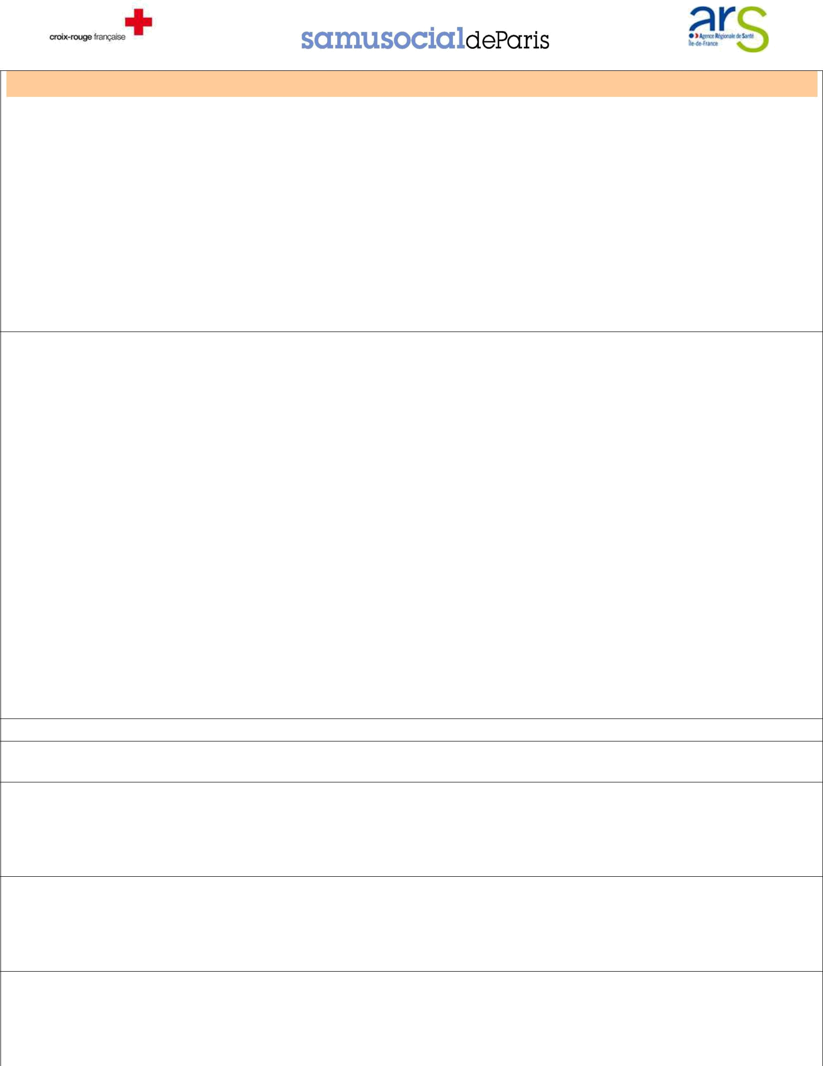
Observations/ Observations

C – Orientation (systématique : cocher au moins une des 4 cases)
Orientation (systematically : fill at least one of four cases)

 |  | C1 |  | C2 |  | C3 |  | C4 |  |  | C1 |__|
 |  | Urgences Hospitalières  Hospital emergency |  | Psycho/  psycho |  | PMI/  maternal protection |  | PASS pédiatrique  Pediatric Permanent Healthcare
 |  |  |  |  |  |  |  |  |  |  | C2 | |__|
 | En urgence/urgency | □ lieu /place: |  |  |  |  |  |  |  |  | C2a |__|
 |  | ……………………………. |  |  |  |  |  |  |  |  | C3 | |__|
 |  |  |  |  |  |  |  |  |  |  | C3a |__|
Dans la semaine/
During the week
 | Dans la semaine/  During the week |  |  | □ |  | □ |  | □
 |  |  |  |  |  |  |  |  |  |  | C4 | |__|
 | Les parents sont-ils d’accord pour que nous |  |  | □ Oui/yes |  | □ Oui/yes |  | □ Oui/yes
 |  |  |  | □ Oui/yes |  | □ Oui/yes |  | □ Oui/yes |  |  | C4a |__|
 |  | prenions le RV ?  Do the parents agree for us to take the consultation |  | □ Non/no |  | □ Non/no |  | □ Non/no

Si désaccord : demander aux parents d’y réfléchir => les revoir avec l’IDE coordinatrice/
If they disagree : ask the parents to rethink => meet with Nurse Coordinator :
C5 |__|

C5 Conclusion finale/final conclusion : ……………………………………………………………………………………………

SUIVI PREVU/ PLANNED FOLLOW-UP

QUALIFICATION LIEU/place DATE/date NOM/name COMMENTAIRE/comments

